Lab 6 Worksheet Earthquakes
Name ______ (-2 points if missing)
Date _______
Use your textbook, lab and lecture PowerPoints, and internet as needed to answer all questions in each of the 2 parts. Please explain everything in your own words.
Part 1
- Explain earthquake frequency on planet earth.
  - Earth being an active place, earthquakes happen. On an average Magnitude 2 and smaller earthquakes several times a day in the entire world. Those Major earthquakes with a magnitude of more than7 happen more than one times in a month and those whose Magnitude is 8 and above, happens once in a year.
- Describe the type of movement experienced with P and S waves.
  - P waves usually travel through any material be it solid, gas or liquid.
  - S waves Move only through the solids and stopped by gases and liquids.
- What is the name of the process which is being demonstrated in the diagram below?
  - 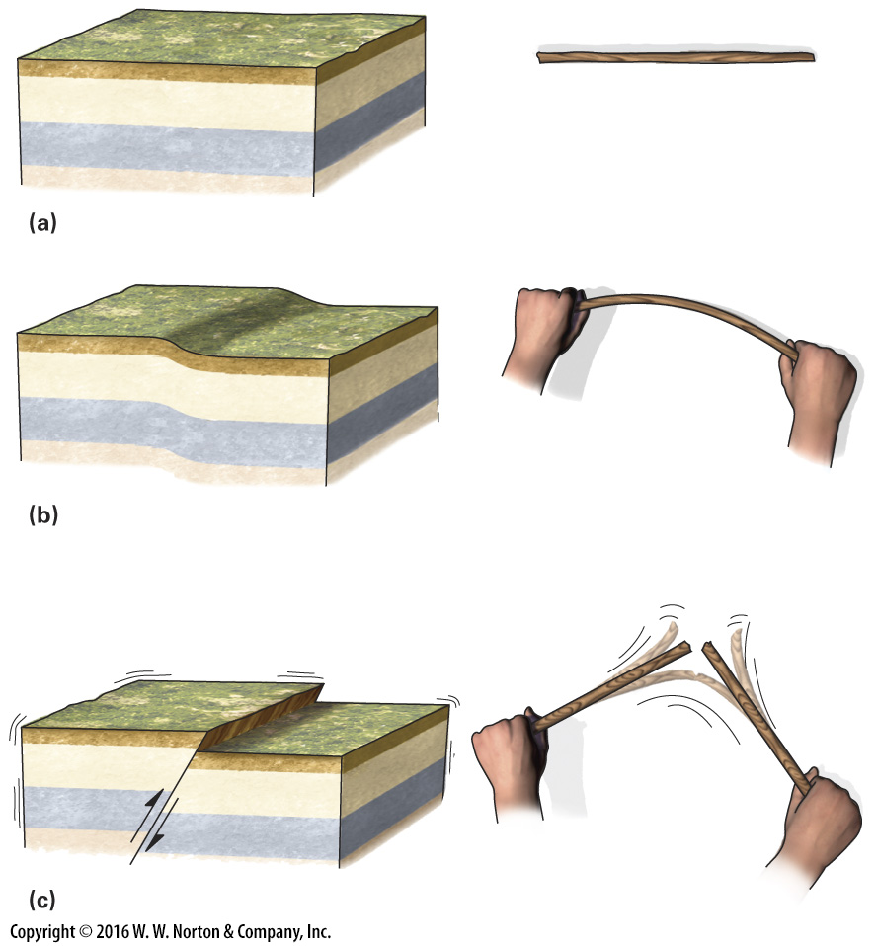
  - faulting
- Which plate boundary type experiences most of the biggest earthquakes on the planet?
  - Convergent plate boundary
- Explain why we need data from at least 3 seismic stations to pinpoint the location of an earthquake.
  - This is because three is the absolute Minimum required to triangulate, assuming the accurately synchronized times of the arrival of the shock waves. Also their differences in time of their occurrences is used in determining the epicenter generated at each station. When the time difference is greater, that indicates that the epicenter is farther away.
- Explain what is meant by amplification of earthquake waves through loose sediments compared to igneous rock?
  - This means that there could be an increased in the shaking levels at a site .It happens when focusing the seismic energy that is as a result of the geometry of the velocity structure of the sediments.
- Where was the biggest earthquake ever recorded by humans, and what magnitude was it?
  - Chile.it had a magnitude of 9.5
- Identify 4 of the many problems caused by earthquake?
  - Ground shaking
  - Ground rupture
  - Tsunamis
  - Landslide
Part 2
- How many more times shaking is there between a 5.0 and a 7.0 earthquake?
  - 20 times
- How much more energy is released between a 5.0 and a 7.0 earthquake?
  - 205470 tons
Use the following diagram to answer questions 11-13.
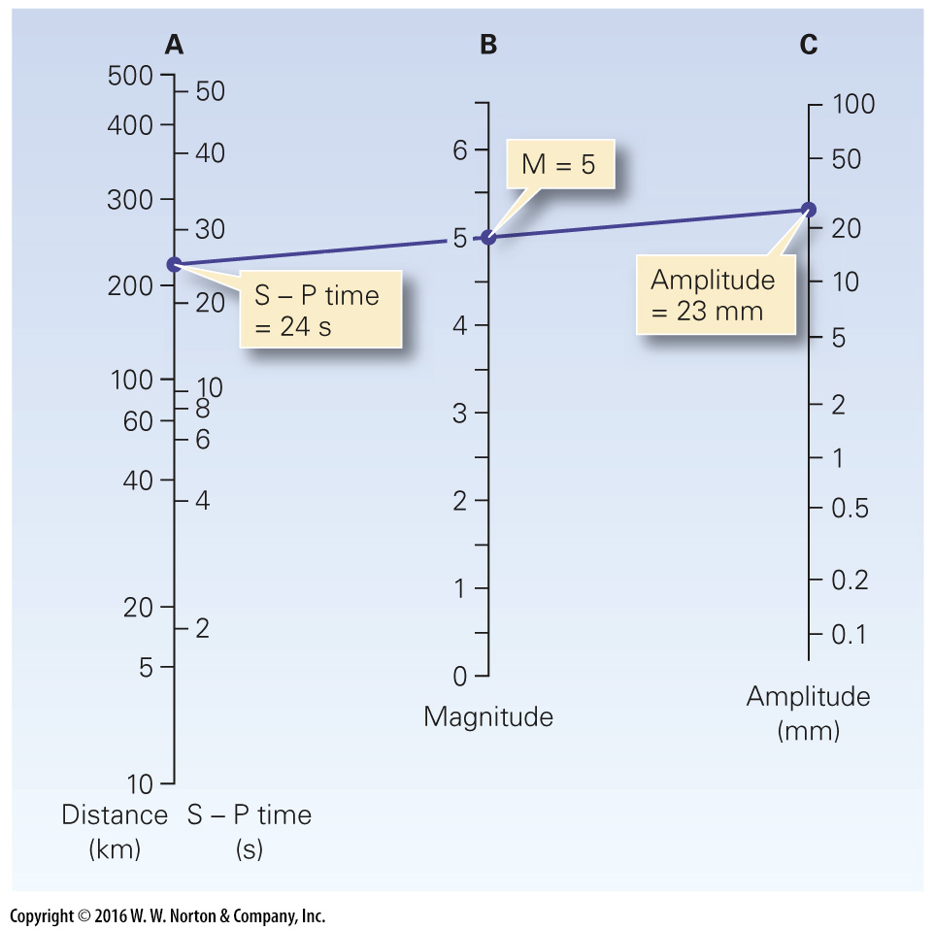
- If the amplitude is 0.5, and the magnitude of the quake is 4.3, what is the time difference between the P and S waves?
  - 10 s
- If the earthquake is 100 miles from the seismic station, and the amplitude is 1 mm, what is the magnitude of the quake?
  - 3.5
- If the amplitude is 100 mm, and the magnitude of the quake is 6.0. how far away from the seismic station was the quake?
  - 40

- Below is an image from Anchorage, Alaska, after the 1964 earthquake. What was the magnitude of this quake?
  - 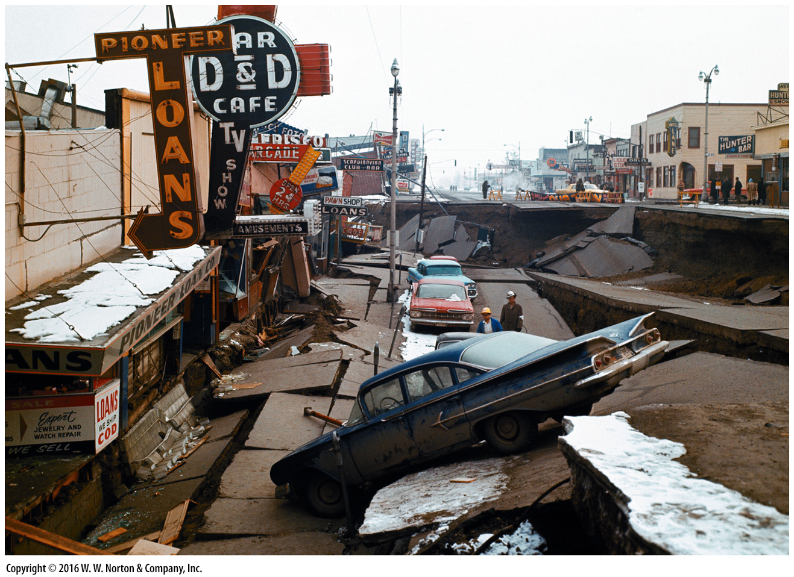
  - 9.2
- From this same picture, how would you rate this quake on the Mercalli scale and why?
  - xi
  - There was structural damage and ground fissures.
- Explain why an 8.0 moment magnitude earthquake on the mid-Atlantic rift at the equator would not have a rating on the Mercalli scale.
  - This is because at the Mid-Atlantic rift, ridges are offset by some long transformations faults. Here, most earthquakes are located along the transform faults instead of the spreading segments.

